Service action:
The Service action can perform its service on the current form or on any other form in the database. The Service action can work with a BMC Remedy AR System web service to obtain external services or with a Set Fields filter action to consume an internal BMC Remedy AR System server service
Executes when a Service active link action is performed. The filter accesses a request with the field values passed by the active link action and those retrieved from the database, if any, and returns output values to the calling request. No other database operation
is performed. See “Service action” on page 127.
If the filter runs a Push Fields action, the output field value list is
Not affected. If the filter runs a Set Fields action, the output field value list uses any modified values.

Use the Service action in:
„
Active links
„
Filters
„
Escalations
The Service action triggers filters that have an Execute On condition of Service.
You can now use the Service action in all three types of workflow:
„Active links and filters—The Service action uses the input field mapping along
with an optional database request ID to provide output data to the current
transaction for use in further processing. In this case, no changes are required to
the database.
„Escalations—The Service action used in an escalation does set values in the
database, if output data is provided.The Service action uses fields and values
in the input field mapping to determine values for the output field mapping. The Service action can perform its service on the current form or on any other form in
the database. The Service action can work with an AR System web service to obtain external services or with a Set Fields filter action to consume an internal AR System service. The filter called by the Service action accesses a request by using the input field values in the transaction, or by retrieving values from the database, and returns
output values to the calling request.

NOTE
If the filter started by a Service action runs a Push Fields action, the output field
value list is not affected. If the filter runs a Set Fields action, the output field value
list uses any modified values.
WARNING
If a user is running a pre-7.1 version of BMC Remedy User and activates a Service
Active link action, the user receives the following error message:
AR Warning 96 (Capability not supported by this AR System client)

Understanding the working of buttons and menu items with active links
Buttons and menu items are fields in BMC Remedy AR System server; you can use them in workflow as in any other field. For example, an active link can show, hide, enable, or disable buttons and menu items. Because these fields do not have data behind them and they are used to control workflow, they are called control fields.
You can associate more than one active link with a button or menu item. A good use of this capability is to define active links that execute based on current conditions, such as the platform on which the tool is running.
For example, you can define an active link to execute only if the tool is running on a computer. You can then associate another active link with the same field--this time defining the active link so that it executes only if the web client is running. Users on either platform can then perform the same action to execute the appropriate active link for their platform.
Active links as buttons or menu items

Regular, computed, and dynamic groups
You can create the following groups in the Group form.
- Regular groups — Explicit groups that you create and to which you assign a specific list of users. For information about assigning users to groups, see Adding and modifying user information.
- Computed groups — Explicit groups that you create and to which users are assigned based on the memberships of explicit groups included in an expression. For example, you can create a computed group definition such as (A AND B) OR C AND NOT D. This computed group includes the list of users who are members of both groups A and B, or members of group C, but not members of group D.
Computed groups make groups easier to manage. You can manage your users in a limited number of regular groups, and use computed groups based on these regular groups for more complex access control without the need to make changes in multiple groups.
- Dynamic groups — Implicit groups are similar to the reserved Assignee Group group in that the contents of special fields determine group membership. For more information, see Dynamic group access.
BMC Remedy AR System provides two types of groups:
- Explicit groups — Groups to which you must manually assign users in the User form. When a user becomes a member of a group, the user is given access to all objects and fields to which the group is granted access.
Explicit groups that you create are defined for a particular server. If you move the objects to a new server with its own defined explicit groups, you might need to resolve permission conflicts. Consider using a deployable application, which uses role permissions that can be mapped to different groups on different servers. For more information, see Role-based access.
For information about assigning users to groups, see Adding and modifying user information.
- Implicit groups — Groups that depend on specific user circumstances and situations. Users belong to these groups based on specific conditions, such as the contents of special fields within each request. You do not directly assign users to implicit groups.
Any dynamic groups that you create are also implicit groups
arforkd description. The arforkd process reduces the amount of memory an BMC Remedy AR System server uses when forking new processes as a result of filters that run processes, set fields to values returned from processes, or send email notifications

Change management approval process
Steps for Change Management approval process are as follows:
- In the Approval Process Configuration form, select Process Designer approval phase for change application.
- Mark all OOTB approval phases for change management as offline.
- Create PD Change Approval process.
- Create Mapping PD Change Approval process on Process Mapping Form
- Create Change Request with mapping. The PD process gets mapped.
- Approval task is displayed under Task tab
- The Approval task has the status as Assigned.
- Update the Change Request status to Planning in Progress.

Note:Approval action is triggered only when Change Request status is Planning in Progress.

Best Practices for Change Management Approvals
- Guidelines on Auto Transitioning Change Request: When the Change Request is created from Process Designer Task Action, by default it gets created in Request for Authorization.
The Standard Change Process is as follows:
Draft > Request For Authorization > Request For Change > Planning In Progress > Scheduled For Review > Scheduled For Approval > Scheduled > Implementation In Progress > Completed > Closed
In all cases, Change Manager or Change Coordinator is not expected (apart from approvals) to manually intervene when the Change Request is required in the process. It is recommended to create custom Change Process Flow as follows:
Draft > Request For Authorization > Planning In Progress > Scheduled > Implementation In Progress > Completed > Closed
- You can then attach this flow to your change request template (For example CLM Change Template) as shown in the following image:

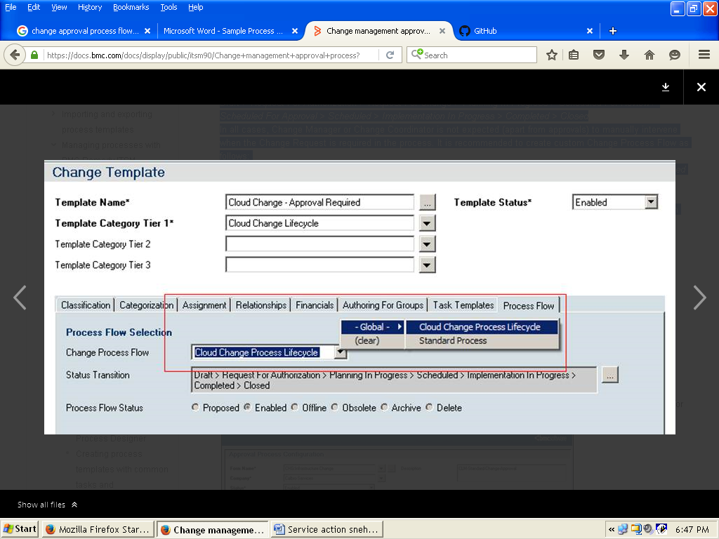

If a Change Approval is required, it is recommended to configure the approval as shown in the following example for CLM - Change Approval Configuration

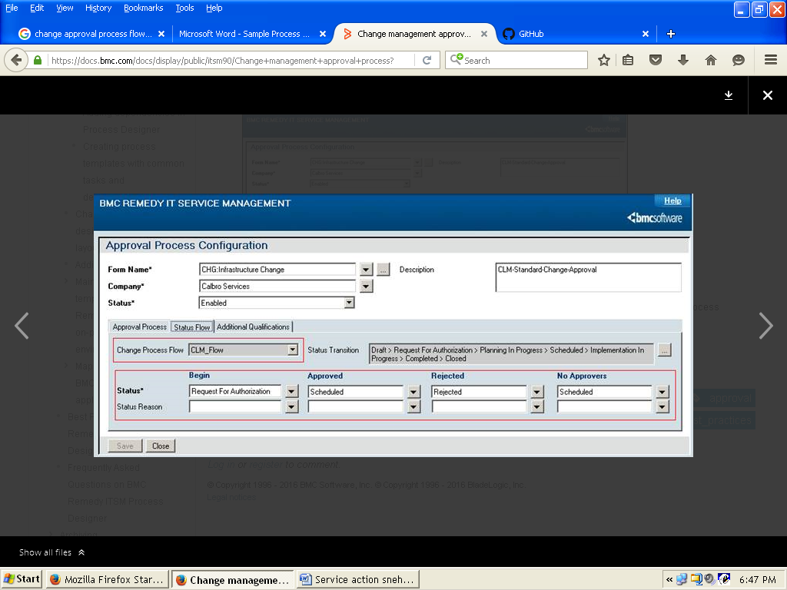

You must set the Process Designer Process to Schedule status of the Change Request. When the Process Designer process is complete, the status of the Change Request automatically turns to Complete.

Creating a request SLA

To create a request SLA
- Log on to BMC Remedy Mid Tier as a BMC Remedy administrator.
- From the Home page, select Applications > Process Designer > Process Designer Configuration.
The Configuration Console opens.
- Select the SLA tab.
- Click the Add icon next to the Request SLAs section.
The SLA Configuration window opens.
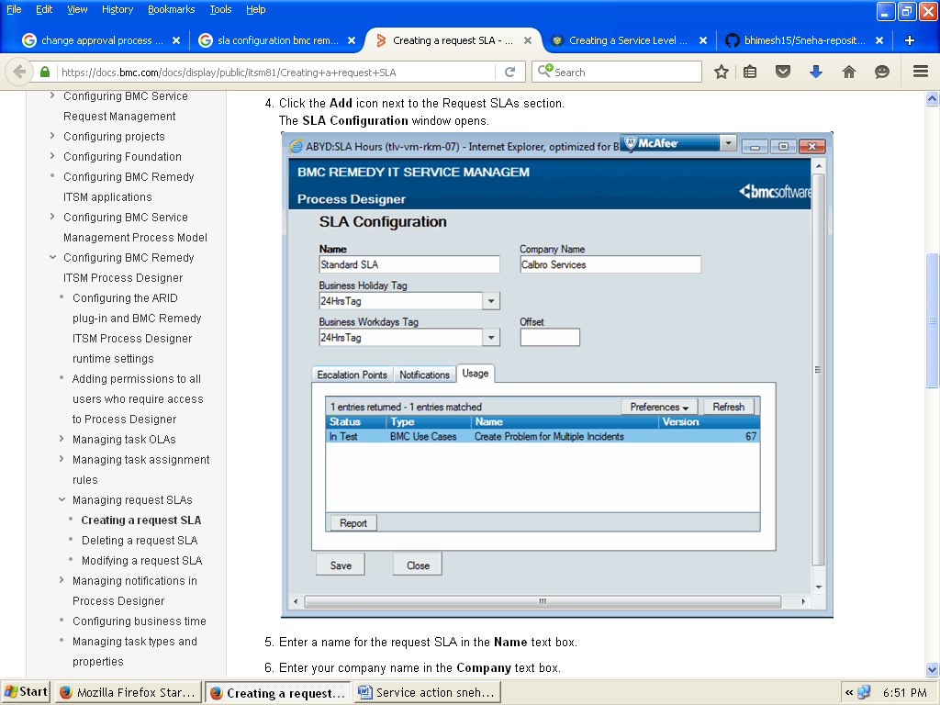
• Enter a name for the request SLA in the Name text box.
• Enter your company name in the Company text box.
• Select the tag from the Business Holiday Tag drop-down menu. This references from the Holiday Schedule defined as part of the BMC Remedy Application Administration.
• Select the tag from the Business Workdays Tag drop-down menu. This is a reference to the Working Days Schedule defined as part of the BMC Remedy Application Administration.
• Enter value in the Offset field. This is the time zone offset (in hours) from the BMC Remedy server time; Range is -12 to +12.
You can set the offset value to support BMC Remedy ITSM Process Designer clients in different time zones from the BMC Remedy AR System server.
• On the Escalation Points tab, select the breach time from the Days, Hours, and Minutes drop-down menus.
Note
Breach time is the time required to meet the SLA. This value relates to working time, and not elapsed time.
• Select the percentage of the breach time from the Percentage drop-down menu at which to send a warning notification to the person or group specified on the Notifications tab.
• On the Notifications tab, perform one of the following:
- Add a notification.
- Modify a notification.
- Delete a notification.
• Click Save.

